Smart Electric Meter Provision Platform

Submitted by

AKASH BERA (13000215012)

NEERAJ KUMAR SINGH (13000215062)

NITESH KUMAR (13000115049)

VISHAL VATSAL (13000215122)

Under the guidance of DR. CHANDRAMA SHAW

Submitted for the partial fulfillment for the degree of Bachelor of Technology in Computer Science and Engineering



Techno India

EM 4/1, Salt Lake, Sector – V, Kolkata – 700 091.

**ACKNOWLEDGEMENT**

We would like to express our sincere gratitude to DR. CHANDRAMA SHAW of the department of Computer Science and Engineering, whose role as project guide was invaluable for the project. We are extremely thankful for the keen interest he / she took in advising us, for the books and reference materials provided for the moral support extended to us.

Last but not the least we convey our gratitude to all the teachers for providing us the technical skill that will always remain as our asset and to all non-teaching staff for the gracious hospitality they offered us.

Place: Techno India, Salt Lake

Date: 26/11/2018

AKASH BERA (13000215012)

NEERAJ KUMAR SINGH (13000215062)

NITESH KUMAR (13000115049)

VISHAL VATSAL (13000215122)

Department of Computer Science and Engineering

Techno India, Salt Lake

Kolkata – 700 091

West Bengal, India.

## **Approval**

This is to certify that the project report entitled ***“SMART ELECTRIC METER PROVISION PLATFORM”*** prepared under my supervision by ***AKASH BERA(13000215012),NEERAJ KUMAR SINGH (13000215062),NITESH KUMAR (13000115049),VISHAL VATSAL (1300215122)*** be accepted in partial fulfillment for the degree of Bachelor of Technology in ***COMPUTER SCIENCE AND ENGINEERING.***

It is to be understood that by this approval, the undersigned does not necessarily endorse or approve any statement made, opinion expressed or conclusion drawn thereof, but approves the report only for the purpose for which it has been submitted.

……………………………………….. … ………………………………………

Name & Designation of Internal Guide Name & Designation of the HOD

|  |
| --- |
| **Contents: Page Numbers**  1. Introduction 8  1.1 Briefing 8  1.2 Problem Domain 8  1.3 Related Study  2. Problem Definition 9  2.1 Scope 9  2.2 Exclusions 9  4. Project Planning 13  4.1 Software Life Cycle Model 13  4.2 Scheduling 16  4.3 Cost Analysis 18  5. Requirement Analysis 19  5.1 Requirement Matrix 19  5.2 Requirement Elaboration 20  5.2.1 LGN-1 Register As Customer/Admin/Supplier/Coordinator  5.2.1.1LGN-1.1 Login  5.2.1.2 LGN-1.2 Authenticate User  5.2.1.3 LGN -1.3 Authorize User  5.2.1.4 LGN-1.4 Validate User  5.2.2 CUST-1 Customer Home Page  5.2.2.1 CUST-1.1 Display all job related to that customer on home page  5.2.2.2 CUST-1.2 Request for new job  5.2.2.3 CUST-1.3 Check current status of job  5.2.2.4 CUST-1.4 Billing  5.2.2.5 CUST-1.5 Prepaid and Postpaid Recharge  5.2.2.6 CUST-1.6 Product Specification  5.2.3 ADMIN-1 Retrieve list of Customer requests  5.2.3.1.1 ADMIN-1.1 Approve Customer Request  5.2.3.1.2 ADMIN -1.1.1 Retrieve list of available suppliers  5.2.3.1.2 ADMIN- 1.1.2 Assign any available coordinator to customer request  5.2.3.2 ADMIN-1.2 Bills of customer with payment status  5.2.3.3 ADMIN-1.3 Update new plan  5.2.3.4 ADMIN-1.4 Product Page  5.2.3.5 ADMIN-1.5 Get list of all customers  5.2.3.5.1 ADMIN-1.5.1 Customer Profile  5.2.3.6 ADMIN-1.6 Get list of all coordinators  5.2.3.6.1 ADMIN-1.6.1 Coordinator Profile  5.2.4 COORD-1.1 Retrieve all mapped request  5.2.4.1 COORD-1.2 Send email to area engineer with details of customer  5.2.4.2 COOR-1.3 Send email to customer with detail of engineer  5.2.4.3 COORD-1.4 Cancel/Reopen Job  6. Design 24  6.1 Technical Environment  6.2 Hierarchy of Modules  6.3 Detailed Design  6.3.1 Customer  6.3.2 Admin  6.3.3 Coordinator  6.4 Test Plan  7. Conclusion 31  7.1 Project Benefits  7.2 Future Scope for improvements  8. References / Bibliography 32 |

**List of Tables: Page Numbers**

Table 1 13

Table 2 14

**List of Figures: Page Numbers**

Fig. 1 16

Fig. 2 17

Fig. 3 19

Fig.4 26

Fig.5 28

Fig.6 30

**1. INTRODUCTION**

**1.1 Briefing:**

Electricity department has faced lots of problem in installing, maintaining meters and also providing bill payment options to their customers.

Currently, getting electricity meters encompasses several offline and physical steps. Hence management and provisions of such essential facilities in India need to be done in much easier way which can only be incorporated using digitalization.

For the proper installment, remove or exchange of a meter, customer has to contact the electricity department physically and then only they able to request for a service. The above steps generally take much time and efforts for the installment, remove or exchange of a meter.

We can design a WebApp which can digitize all the processes involved in providing meter to customers and also make the billing process more efficient. This way the customer can easily request a service via the WebApp.

Ease of access to customers. The platform will provide the service and also maintain the billing as well. The service can be requested by the customer by anytime and anywhere. All they just need is access to website. Status will be transparent to the customer and they can exactly get to know their request’s current status. Customer will be provisioned with access to prepaid and postpaid services as well.

**1.2 Problem Domain**:

In the present billing system the distribution companies are unable to keep track of the changing maximum demand of consumers. The consumer is facing problems like receiving due bills for bills that have already been paid as well as poor reliability of electricity supply and quality even if bills are paid regularly. The remedy for all these problems is to keep track of the consumers load on timely basis, which will held to assure accurate billing, track maximum demand, easy installation and maintenance of meters.

1. **PROBLEM DEFINTION**

We can see a person standing in front of our house from electricity board, whose duty is to read the energy meter and handover the bills to the owner of that house every month. This is nothing but meter reading. According to that reading we have to pay the bills. The main drawback of this system is that person has to go area by area and he has to read the meter of every house and handover the bills. Many times errors like extra bill amount or notification from electric board even though the bills are paid are common errors. Theft of electricity is also a major concern in India; people steal electricity via overhead wires to power their small shops or homes.

Physically going to the electricity board to get a connection or pay bills can be tiresome as well. To overcome this drawback we have come up with an idea which will eliminate the third party between the consumer and service provider, even the errors will be overcome.

**2.1 SCOPE:**

As almost every home is installed with a meter so the scope of this problem is quite large. A minor change in data at one place can affect all other customers. At a large scale these small errors can lead to major problems.

**2.2 Exclusion**:

There are some small villages or rural areas in India were electricity has not reached so, this platform cannot help people living in these areas. But, if they get electricity in the future our platform can help them in paying their electric bills, request for meter installation, etc. Areas where internet is yet to take off or where there is no internet available our WebApp would not work as it requires a connection to the internet.

1. **RELATED STUDY**

To understand the depth of our project and the requirements we need to have a look at a few things.

**SMART METERS:**

The term *Smart Meter* often refers to an [electricity meter](https://en.wikipedia.org/wiki/Electricity_meter), but it also may mean a device measuring [natural gas](https://en.wikipedia.org/wiki/Natural_gas) or [water](https://en.wikipedia.org/wiki/Water) consumption.

Similar meters, usually referred to as [interval](https://en.wikipedia.org/wiki/Intervalometer) or time-of-use meters, have existed for years, but "Smart Meters" usually involve real-time or near real-time sensors, power outage notification, and power quality monitoring. These additional features are more than simple automated meter reading (AMR). They are similar in many respects to [Advanced Metering Infrastructure](https://en.wikipedia.org/wiki/Advanced_Metering_Infrastructure) (AMI) meters. Interval and time-of-use meters historically have been installed to measure commercial and industrial customers, but may not have automatic reading.

Research by the UK consumer group, showed that as many as one in three confuse smart meters with energy monitors, also known as in-home display monitors. The roll-out of smart meters is claimed to be one strategy for saving energy.

Since the inception of electricity [deregulation](https://en.wikipedia.org/wiki/Deregulation) and market-driven pricing throughout the world, utilities have been looking for a means to match consumption with generation. Non-smart electrical and gas meters only measure total consumption, providing no information of when the energy was consumed. Smart meters provide a way of measuring this site-specific information, allowing utility companies to charge different prices for consumption according to the time of day and the season.

Utility companies say that smart metering offers potential benefits to householders. These include, a) an end to estimated bills, which are a major source of complaints for many customers b) a tool to help consumers better manage their energy purchases—stating that smart meters with a display outside their homes could provide up-to-date information on gas and electricity consumption and in doing so help people to manage their energy use and reduce their energy bills. Electricity pricing usually peaks at certain predictable times of the day and the season. In particular, if generation is constrained, prices can rise if power from other jurisdictions or more costly generation is brought online. Proponents assert that billing customers at a higher rate for peak times encourages consumers to adjust their consumption habits to be more responsive to market prices and assert further, that regulatory and market design agencies hope these "[price signals](https://en.wikipedia.org/wiki/Price_signal)" could delay the construction of additional generation or at least the purchase of energy from higher priced sources, thereby controlling the steady and rapid increase of electricity. There are some concerns, however, that low income and vulnerable consumers may not benefit from intraday time-of-use tariffs.

An academic study based on existing trials showed that homeowners' electricity consumption on average is reduced by approximately 3-5%.

The ability to connect/disconnect service and read meter consumption remotely are major labor savings for the utility and can cause large layoffs of meter readers.

**CONVENTIONAL WAY TO GET A NEW CONNECTION:**

Steps involved are:

1. **SUBMISSION OF APPLICATION**:-

Obtain a blank application form from the respective electricity supply company.

2. **SPOT INSPECTION**:-

The officials of the electricity company will inspect the premises before according sanction for power connection. The officials will give you prior notice about the date, time and other details of, when spot inspection will be carried out. It is obligatory on the part of the consumer to be present while inspection is done. After inspection, the officials will decide the point of entry of supply mains, the position of mains, cut-outs, circuit breakers, meters etc.

3. **FEASIBILITY**:-

After spot inspection the application, the electricity supply company will ascertain whether it is feasible to provide power supply connection. If feasible the same will be intimated to you along with the fees to be paid, voltage, sanctioned load at which supply will be given and the point of commencement of supply.

4. **ESTIMATE AND POWER SANCTION**:-

After the spot inspection is over, the electricity supply company will intimate you the power sanction and also the amount to be remitted by you towards service line, initial security deposit etc.

5. **ISSUE OF WORK ORDER AND SERVICING**:-

If all the above formalities are followed the electricity company will issue the work order. Thereupon the concerned Junior Engineer/Assistant Engineer will draw the materials from stores and arrange to service the power supply.

**4. PROJECT PLANNING**

**4.1 Software Life Cycle Model**

Any software development project, a methodology should be followed to ensure project consistency and completeness.The Web development life cycle includes the following phases: ***planning***, ***analysis*,** ***design******and development*, *testing***, and***implementation and maintenance***.

|  |  |
| --- | --- |
|  |  |
| Web development phase | Questions to ask |
| **Planning** | • What is the purpose of the Web site  • Who will use this Web site  • What are their computing environment  • Who owns and authors the information on the Web site |
| **Analysis** | * What information is useful to the user |
| **Design and development** | • What type of Web site layout is appropriate  • What forms of multimedia is helpful to the user |
| **Testing** | • Is the Web site content correct  • Does the Website functions correctly  • Are users able to find the information they need  • Is the navigation easy to use? |
| **Implementation and**  **Maintenance** | • How is the Web site published  • How is the Web site updated  • Who is responsible for content updates  • Will the Web site be monitored |

Table 1.

## **Web site Planning:**

Involves the identification of the Web site goals or purpose. The question to ask is: What is the purpose of this Web site?

In addition to understanding the Web site purpose, you should also ask: Who will use the Website? or knowing the target audience in terms of: age, gender, computer literacy, etc. Understanding the computing environment will allow the designer to know what type of Technologies to use.

The last question is to ask who will provide the information included in the Web site.

## **Web Site Analysis:**

## During this phase, the Web designer needs to make decisions about the Web site content and functionality.

It includes a detailed analysis of the content of the Website in terms information covered, processing required, etc.

## **Web Site design and Development**

## After, the purpose of the Website has been found and the content has been defined, we need to organize the content of the Website. Many ways to organize the Website exists. Here are some general pointers:

|  |  |
| --- | --- |
| **Elements** | **Purpose** |
| Titles | Use simple titles that clearly explain the purpose of the page |
| Headings | Use Headings to separate main topics |
| Horizontal rules | Use horizontal rules to separate main topics |
| Paragraphs | Use paragraphs to help divide large amount of data |
| Lists | Utilize list. Numbered or bullet when appropriate |
| Page length | Maintain suitable Web page lengths; about one or two pages are adequate |
| Information | Emphasize the most important information by placing it at the top of a Web page |
| Other | •         Incorporate a contact e-mail address  •         Include the date of the last modification |

## Table 2

## **Web site testing:**

## A Web site should be tested at various stages of the Web design and development. This testing should include a review of page content, functionality and usability. Some basic steps to test content and functionality are:

* Reviewing for accurate spelling and proofreading content including page titles.
* Checking links to ensure that they are not broken and are linked correctly
* Checking graphics to confirm they display properly and are linked correctly
* Testing forms and other interactive page elements
* Testing pages to check for speed of loading on lower speed connection
* Printing each page to check how page s print
* Testing each Web in several different browser types and versions to verify they display correctly

Usability is the measure of how well product, allows users to accomplish their goals. Usability testing is a method by which users of a Web site are asked to perform certain tasks in an effort to measure the ease of use of the product.

## **Site Implementation and Maintenance:**

Once the Web site testing is complete and any required changes have been made, the Web site can be implemented. Implementation of a Web site means publishing the Web site or uploading it into a Web server.

Once, the Web site has been implemented, its maintenance will include updating the information content by removing the outdated one and putting in the new one. Periodical checking of the links is also necessary to ensure that they are still active. Finally, Website monitoring is another key aspect of maintenance. Usually, the Web servers that host the Web sites keep logs about Web site usage.

A **log** is the file that lists all the Web pages that have been requested from the Web site.

Analyzing the logs allows you to determine the number of visitors to your site and the browser types and versions they are using, as well as their connection speeds, most commonly requested pages.

**4.2 Scheduling**

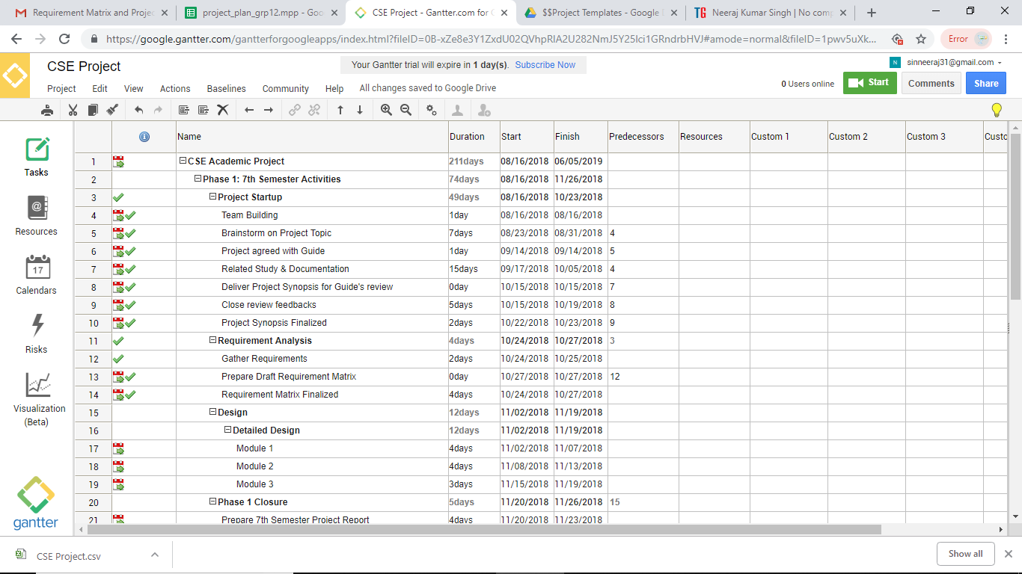

Fig 1.

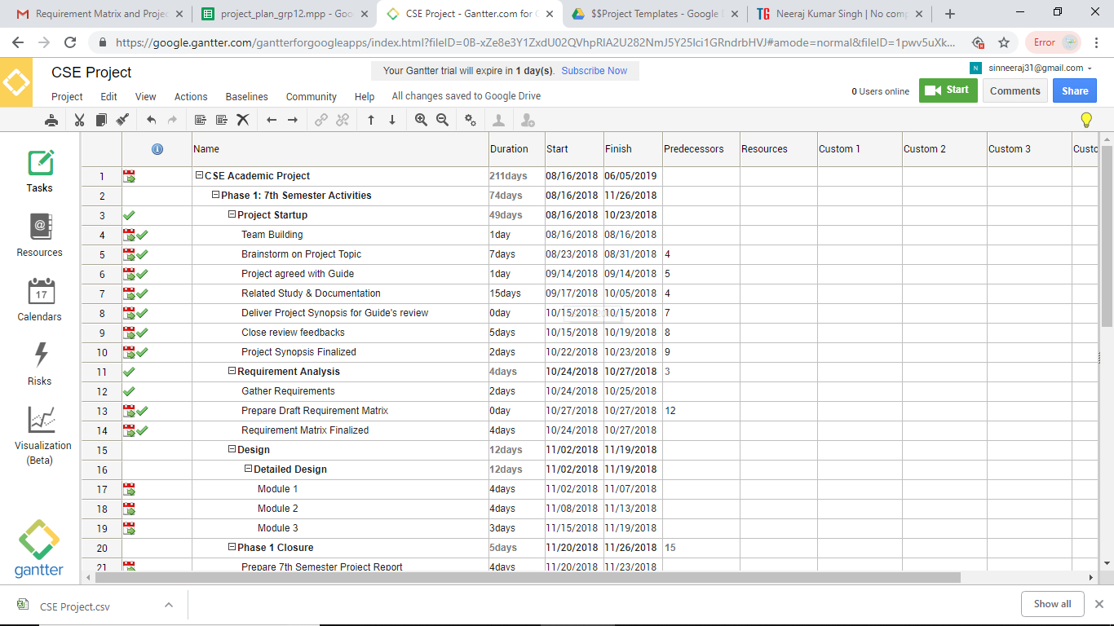

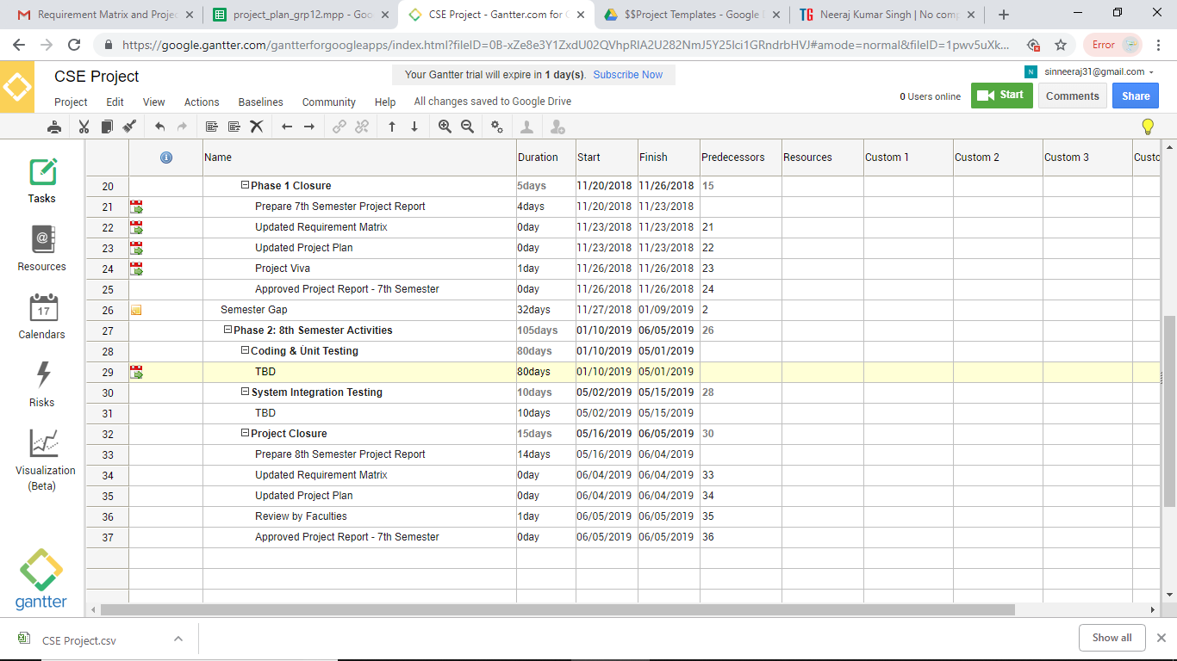

Fig 2.

**4.3 Cost Analysis**

**Costs for technology**To produce an ecommerce website requires a high speed connection to the Internet, a web server, and software.  Other costs that are relevant is the cost of the payment system, whether it is taking online payment directly from the web site or an alternative third-party like Pay pal or more expensively using an online bank.

**Costs for technological development**This will involve a number of programmers who are able to interpret your functional requirements and program/create your website.

**Costs for the consultancy support (design and implementation)**You would require the services of specialists in e-business design and implementation to guide you through this process.

**Running costs**These are an upkeep of the web server and maintenance costs.

**5. Requirement Analysis**

**5.1 Requirement Matrix**

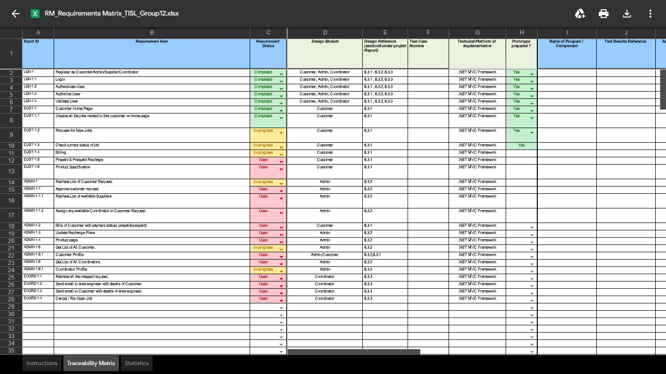

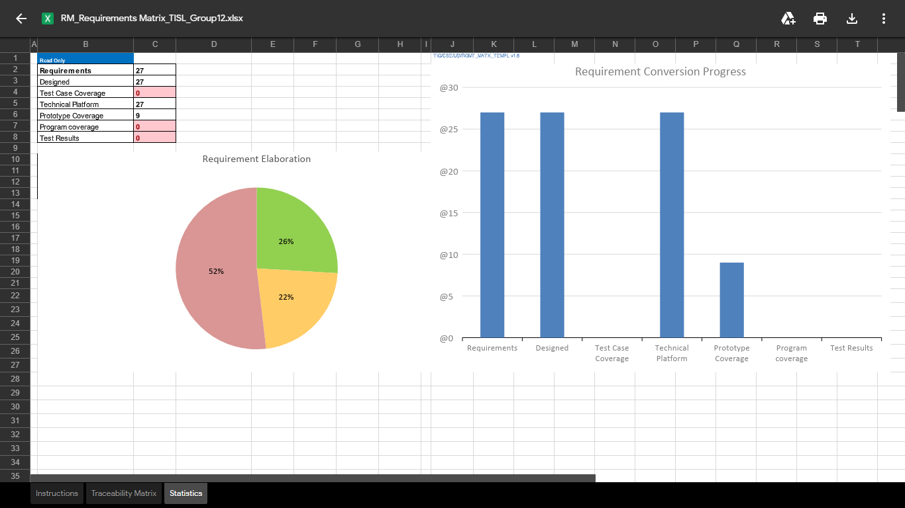

Fig 3.

**5.2 Requirement Elaboration**

**5.2.1 LGN-1 Register As Customer/Admin/Supplier/Coordinator**

This Pageis common to all Customer/Admin/Supplier/Coordinator i.e. Home page or Register page Here All Customer/Admin/Supplier/Coordinator have to give their basic details like Their **Name, Address, Mobile no, Email Id** They also have to set their **username and password**.

**5.2.1.1. LGN-1.1 Login**

After Registration User can login in their Account by giving their **Username and Password**.

**5.2.1.2. LGN-1.2 Authenticate User**

Here User are Authenticated by checking the detail provided are valid or not i.e. **whether password, email,** is in correct format or not. If not user have to reenter.

**5.2.1.3. LGN-1.3 Authorize User**

Once user are authenticated they are Authorized based on request they are applied like… Customer/Supplier/Coordinator

**5.2.1.4. LGN-1.4 Validate User**

Now user are validated by the system by sending the **OTP code to their register email id or mobile** number so the they can do their future job.

**5.2.2 CUST-1 Customer Home Page**

After customer login with their id and password they are directed to their home page.

**5.2.2.1 CUST-1.1 Display All the Job Related to that Customer on Home Page**

Here they get all data related to them like **request status, bill payment, energy consumed**…etc…

**5.2.2.2 CUST-1.2 Request for New Jobs**

Here customer can apply for new connection in their preferred location choice.

**5.2.2.3 CUST-1.3 Check Current Status of Jobs**

On the same customer home page Customer can check their connection status where Customer connection status will display like pending/verified/ completed.

**5.2.2.4 CUST-1.4 Billing**

On this page customer have all the details regarding their bill payment like payment bill details, pending bills, amount left (if prepaid plan).

**5.2.2.5 CUST-1.5 Prepaid & Postpaid Recharge**

Customer Can Choose Prepaid or Postpaid plan according to their comfort in postpaid they have pay some amount early so that they can avoid any late payment fine.

**5.2.2.6 CUST-1.6 Product Specification**

**5.2.3 ADMIN-1 Retrieve List of Customer Request**

Here admin will retrieve all the customer data and their request list.

**5.2.3.1 ADMIN-1.1 Approve Customer Request**

Admin will approve the customer request and mapped them with available supplier.

**5.2.3.1.1 ADMIN-1.1.1 Retrieve List of Available Suppliers**

Here admin will retrieve all the Available supplier list.

**5.2.3.1.2 ADMIN-1.1.2 Assign any Available Coordinator to Customer Request**

Here admin will assign the available coordinator to the customer**.**

**5.2.3.2 ADMIN-1.2 Bills of Customer with payment status (prepaid/postpaid)**

Here customer electricity consumption and respective bill will be generated with the payment detail.

**5.2.3.3 ADMIN-1.3 Update New Plan**

Admin will update any plan if change**.**

**5.2.3.4 ADMIN-1.4 Product Page**

Here all the product details will be available like bill meter, wire, and bulb. Customer can also buy from here.

**5.2.3.5 ADMIN-1.5 Get List of all Customer**

Here list all current customer available who have completed their verification.

**5.2.3.5.1 ADMIN-1.5.1 Customer Profile**

Here all customer profile, their details, purchase history are available**.**

**5.2.3.6 ADMIN-1.6 Get List of all Coordinators**

Here list all current coordinator available who have completed their verification.

**5.2.3.6.1 ADMIN-1.6.1 Coordinator Profile**

Here all coordinator profile, their details, purchase history are available**.**

**5.2.4 COORD-1.1** Retrieve all the mapped request.

Coordinator will retrieve all the mapped request.

**5.2.4.1 COORD-1.2 Send email to area engineer with details of customer.**

Coordinator will send email to area engineer with details of customer.

**5.2.4.2 COORD-1.3 Send email to customer with details of area engineer.**

Coordinator will send email to customer with details of area engineer.

**5.2.4.3 COORD-1.4 Cancel/Reopen job**

Coordinator can cancel or reopen job.

1. **Design**
   1. **Technical Environment**

Windows 10

Microsoft Visual Studio 2015

Microsoft SQL Server 2012

**Technologies**

**```````````````**

Bootstrap

HTML

CSS

.NET MVC

JavaScripts

Jquery

Ajax

**Language -** C#

**6.2 Design Modules**

* **Customer**
* **Admin**
* **Coordinators**

**6.3 Detailed Design**

**6.3.1 Customer Profile**

**````````````````````````````**

1.) Home page -> New Job Request page -> Job type selection page -> Customer details page -> Review page.

2.) Home page -> help desk page

3.) Home page -> check status page

4.) Home page -> Billing Report page.

5.) Home page -> Recharge page -> Post-paid Recharge page -> Charge Incurred Detail page -> Payment page.|-------> prepaid recharge page -> Plan selection page -> payment page.

6.) Home page -> order history ->generate receipt

1. ) home page -> Product page.

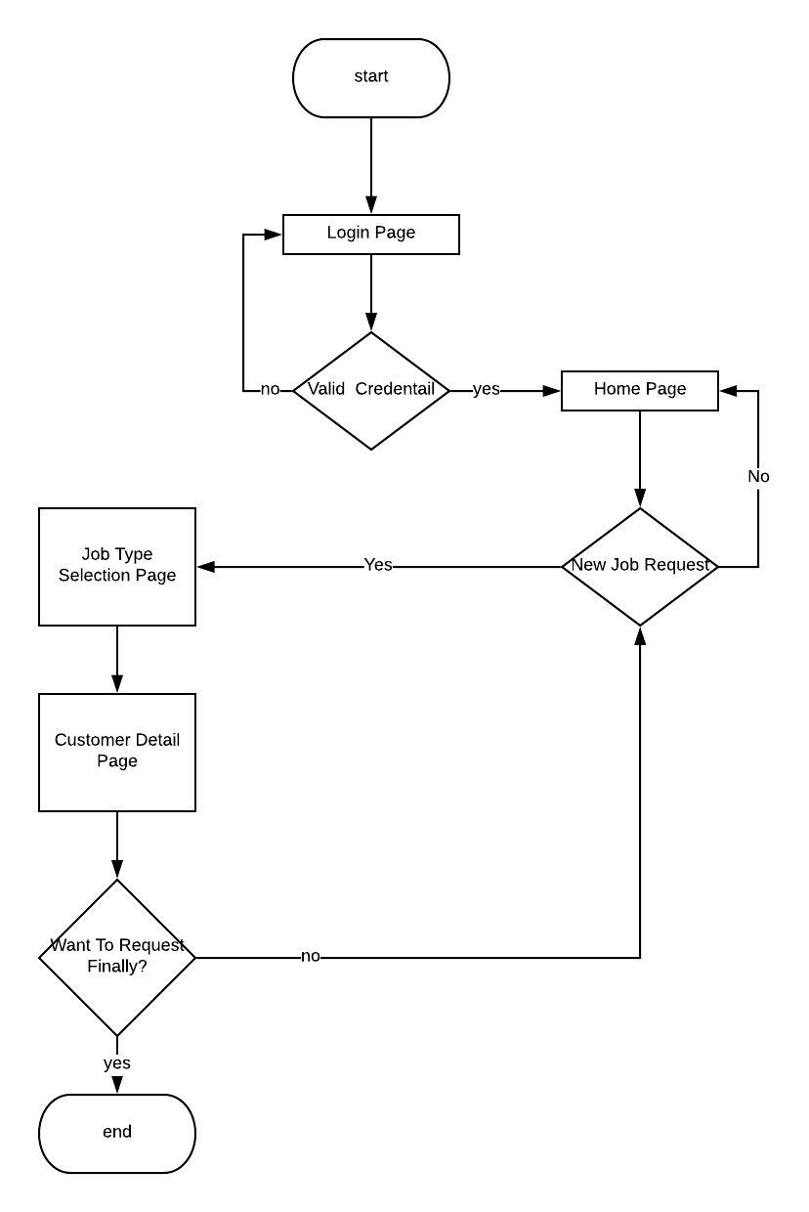

Fig 4.

**6.3.2 Admin Profile**

`````````````````` ```````

1.) Home page -> Customer Request List -> approve request page -> Supplier List page -> Coordinator List page -> Review/Edit mapping page

2.) Home page -> Customer Bill status page -> Remainder Page (for postpaid)

3.) Home page -> Recharge plan list -> Update Recharge Plan page

4.) Home page -> product page -> update Product information page

5.) Home page -> customer list page

6.) Home page -> coordinator list page

1. ) home page -> supplier list page

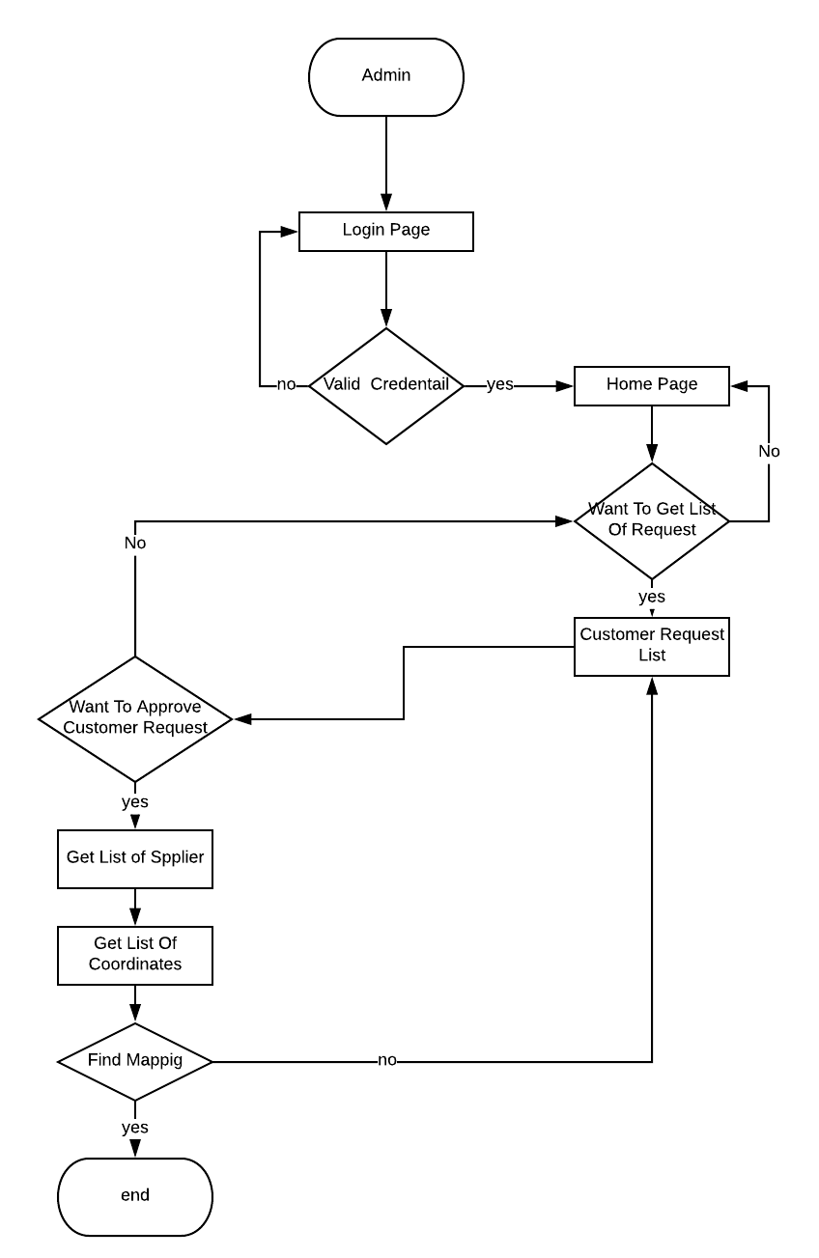

Fig 5.

**6.3.3 Coordinator Profile**

````````````````````````````````

1.) home page -> List of mapped Requests -> emailing area engineer the detail of customer -> emailing customer the details of area engineer.

2.) home page -> List of mapped Request -> Cancel/Reopen Job

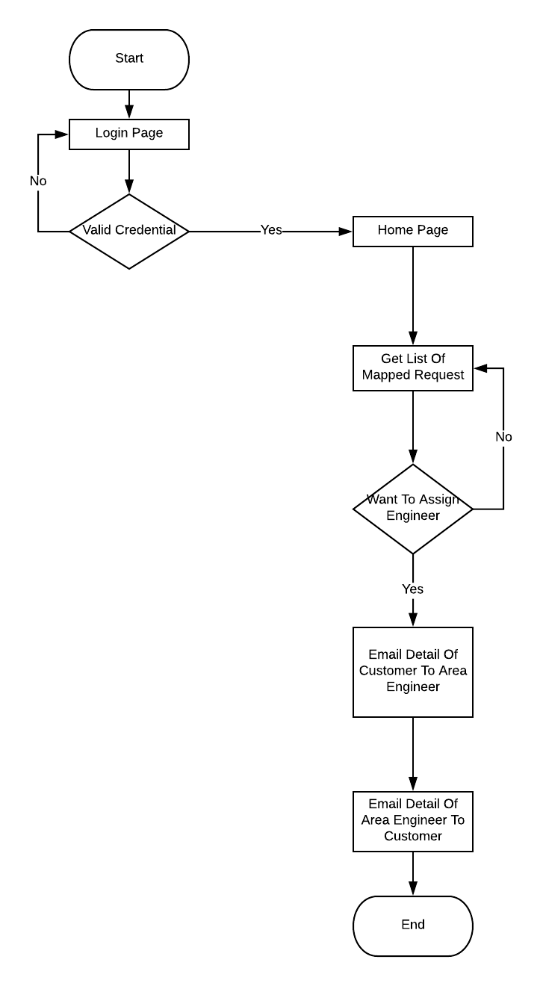

Fig 6

1. **IMPLEMENTATION :**
   1. **Implementation Details:**

7.1.1. Implementing the front - end of the project with bootstrap.

7.1.2. Implementing the backend with .NET MVC 4.0

7.1.3. Configuring the database with Microsoft SQL Server

* 1. **System Installation Steps:**

7.2.1. Install Visual Stdio 2015/17

7.2.2. Install Microsoft SQLServer 2012

1. **CONCLUSION**

The 21st century has brought great discoveries and advancements in the field of technology. These advancements also brought many challenges and require approaches to handle these challenges. Smart metering system is one such approach. In this report, we explained the basic architecture of the smart electricity provision system and a case study.

* 1. **Project Benefits:**

1. With this project we can reduce the gap between the customers and operators.

2. This project gives the real time updates to the customers.

3. Customers can easily access the app from their mobile ,PC and from anywhere where there is net connectivity.

4. Maintenance and installation process is done in an efficient manner.

5. Customer can contact to the Customer care service anytime.

**7.2 FUTURE SCOPE:**

With the advancement in technology our system will adapt as well. Starting from few we will try to build a system which will accelerate India into digital era. Modern techniques like Digital Twins can also be implemented into our system which will make our system more efficient. Pilferage of electric energy which is a major concern in India which can also be tackled.

1. **REFERENCES :**
2. [**https://en.wikipedia.org/wiki/Smart_meter**](https://en.wikipedia.org/wiki/Smart_meter)
3. [**https://www.diva-portal.org/smash/get/diva2:829754/FULLTEXT01.pdf**](https://www.diva-portal.org/smash/get/diva2:829754/FULLTEXT01.pdf)
4. [**http://www.iosrjournals.org/iosr-jeee/Papers/vol1-issue5/B0150610.pdf**](http://www.iosrjournals.org/iosr-jeee/Papers/vol1-issue5/B0150610.pdf)
5. [**http://cs.tsu.edu/ghemri/CS117/ClassNotes/Web%20Development%20Life%20Cycle_small.html**](http://cs.tsu.edu/ghemri/CS117/ClassNotes/Web%20Development%20Life%20Cycle_small.html)
6. [**https://www.researchgate.net/publication/277141436_Automatic_Energy_Meter_Reading_using_Smart_Energy_Meter**](https://www.researchgate.net/publication/277141436_Automatic_Energy_Meter_Reading_using_Smart_Energy_Meter)
7. [**https://www.robabdul.com/business/feasibility-study-cost-benefit-analysis-for-your-new-ecommerce-web-site/**](https://www.robabdul.com/business/feasibility-study-cost-benefit-analysis-for-your-new-ecommerce-web-site/)
8. **https://ieeexplore.ieee.org/document/7823225/**